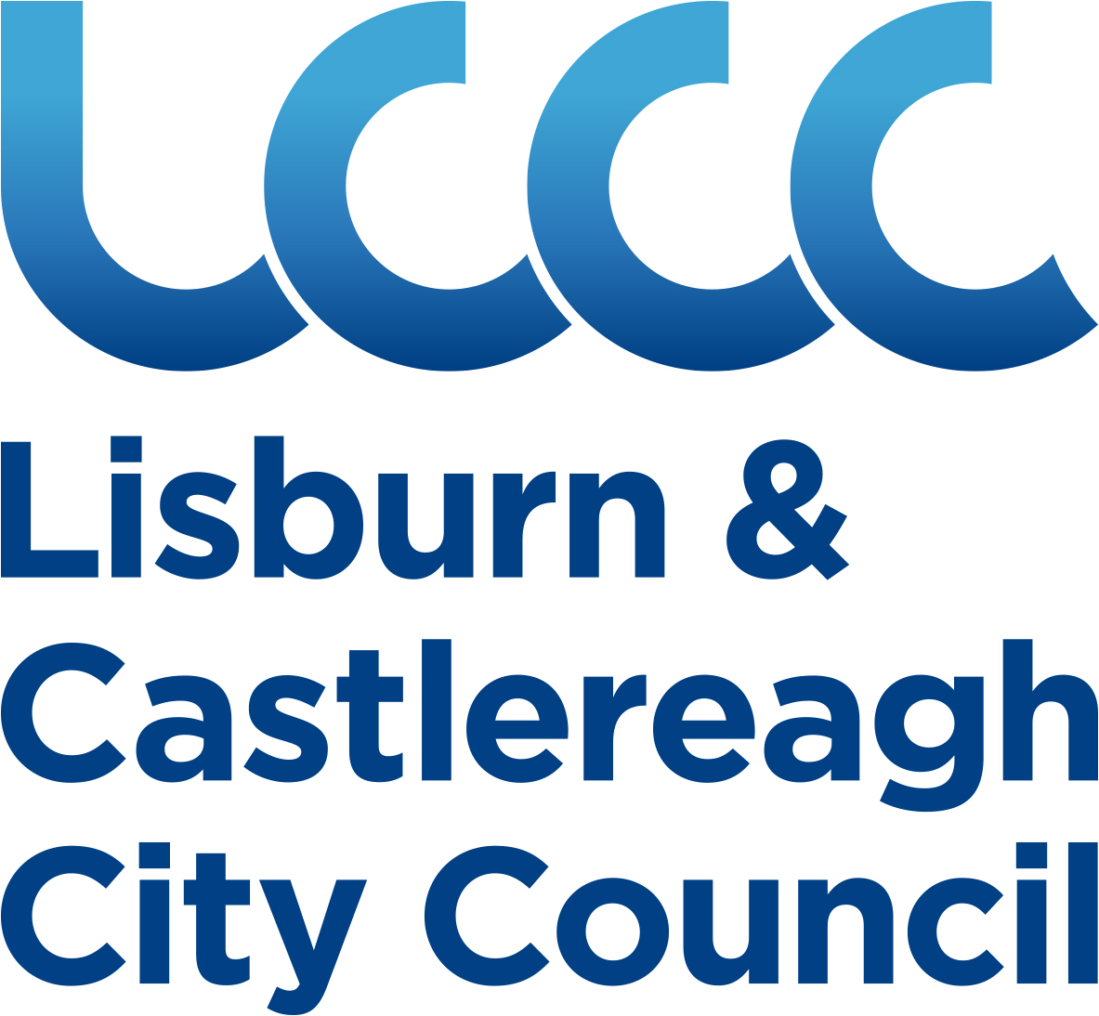 | 

LISBURN & CASTLEREAGH CITY COUNCIL
COCA-COLA BURSARY SCHEME

INTRODUCTION

The Annual Bursary Scheme financed by Coca-Cola is aimed at young people and offers assistance to pursue courses/projects, which would contribute, to their artistic, sporting or community service development. It is intended that the scheme will offer as wide a variety of opportunity as possible, but the course/project proposed by each applicant should offer some of the following qualities:

- Provide an opportunity to gain experience not normally available at a local level.
- Provide an opportunity to improve individual performance/standard in the applicant’s chosen field.
- Provide an opportunity to participate in a course/project with a national or international dimension, which will assist the personal development of the applicant.

NB It is expected that the course/project selected will be residential lasting at least one week. It should not be limited to academic studies. Holiday type courses will not be acceptable. Travel to or participation in competitions or similar events will not be acceptable. Funding assistance through the scheme cannot be used to contribute to University fees.

CRITERIA

To qualify for assistance under this scheme, applicants would have to fulfil the following criteria:

- Reside within the Lisburn & Castlereagh City Council area.
- Between the ages of 14/21 years on 1st April of the year of application.
- Applicants must demonstrate that use of the Bursary will benefit further development of his/her chosen interest, and the wider community.

CATEGORIES

For this year’s bursaries assistance will relate to the following categories:

- Art in the widest form.
- Sport and Active Lifestyle.
- Community Service.

ASSESSMENT OF APPLICATIONS

Applications will be judged on:

- Ability of the applicant.
- Benefit to the applicant.

Final selection will be made by a panel presided over by the Mayor of Lisburn & Castlereagh City Council and part of the selection procedure may involve a short interview.

No correspondence or discussion will be entered into regarding the final decision.

Applications will normally be assessed within one month of the closing date. Preference will be given to first time applicants to the Scheme.

FINANCIAL ASSISTANCE

The amount of grant available is limited and assistance offered may be total or a percentage, depending on the number of applications and the quality of course/project applied for.

Successful applicants will be required to submit documentation of expenditure incurred and a short report at the conclusion of the course/project attended.

Successful applicants may be required, following completion of their course/project, to make a short presentation outlining the benefit from the assistance, at an event later in the year.

APPLICATION

The scheme will be advertised through the local press and applications for Bursaries should be made at least one month prior to the date of course/project for which the individual is seeking assistance.

Application forms can be obtained from:-

Mayor’s Secretary
Island Civic Centre
Lagan Valley Island
Lisburn
BT27 4RL
(028) 9250 9331

LISBURN & CASTLEREAGH CITY COUNCIL
COCA-COLA BURSARIES

(TO BE COMPLETED IN BLACK INK)

APPLICATION FORM
(PLEASE PRINT)

Name _______________________________ |  | Age__________________  Date of Birth __________
Address _______________________________________________________________________________
_______________________________________________________________________________
Telephone (Home)_________________________ | (Business)_______________________
School/College/Place of Work or other

__________________________________________________________________________

HISTORY OF APPLICANT

Please give a short history of involvement in your chosen interest including achievements to date.
________________________________________________________________________________
________________________________________________________________________________
________________________________________________________________________________

BURSARY REQUIRED FOR:

Give details of how you feel you would benefit from such an award, including supporting evidence of specific courses etc.

________________________________________________________________________________
________________________________________________________________________________
________________________________________________________________________________
Is Grant Aid/Support being received from any other source towards the requested project or course? (Please tick) Yes No If ‘yes’ please provide details.

_______________________________________________________________________________
_______________________________________________________________________________
_______________________________________________________________________________
_______________________________________________________________________________
Any other information in support of your application including how the project/course will benefit the wider community. ________________________________________________________________________________________________________________________________________________________________________________________________________________________________________________________________________________________________________________________________

Please indicate if you have previously received assistance through this scheme
(Please tick) Yes No

Please give approximate costs of the course/project as applicable.

Travel £___________ Course Fees £___________

Residential £___________ Other £___________

Total £___________

Please give dates of course/project:
From To

I confirm that I am normally resident in the Lisburn & Castlereagh City Council area

Signature of Applicant ___________________________________________________________

Signature of Parent/Guardian
(if under 18 years of age) _________________________________ Date _________________

Completed application forms in sealed enveloped marked ‘Coca-Cola Bursary’ to be returned to:

Mayor’s Secretary
Island Civic Centre
Lagan Valley Island
Lisburn
BT27 4RL

Please return your application form on or before Friday 1st July

