

**Cemetery Strategy**

**2021 - 2032**

**Contents**

Section Title Page

1. Vision 2
2. Purpose and Aim 2
3. Introduction 2-3
4. Strategic Context 3-4
5. Facilities and Demographic Profile 4-6
6. Cemetery Rules and Regulations 6-7
7. Data Management 7-8
8. Burials and Graves 8-9
9. Health and Safety 9-10
10. Testing of Memorials and Headstones 10
11. Maintenance 10
12. Consultation and Liaison 11
13. Lisburn & Castlereagh City Council Demands and Needs 11-15
14. Lisburn & Castlereagh City Council Conclusion on Needs 15

1. **Vision**

1.1 To meet the needs of bereaved people and the wider community of Lisburn & Castlereagh City Council (LCCC) by creating pleasant, friendly and sympathetic resting places in the Council cemeteries. The Council will endeavour to maintain all its cemeteries to create an accessible, pleasant, peaceful and tranquil environment.

1.2 Lisburn & Castlereagh City Council will manage all burials with compassion, competency and efficiency, so as to ensure the interment is carried out sensitively and in a dignified manner. In recognising that the Lisburn & Castlereagh City Council area is culturally diverse place, the Council aims to meet the needs of all religions, ethnic and cultural groups.

1. **Purpose and Aim** 
   1. Historically, burial by interment in a cemetery has been preferred choice of the majority of bereaved people and the wider community of Lisburn and Castlereagh. Grave plots have traditionally been provided in either Council or local denomination church graveyard. There is good evidence from Council records of a continued need for burial space. That said it is recognised that elsewhere in the United Kingdom that cremation is preferred by most religious denominations and non-religious or other cultural groups and that this is likely to become an increasing trend as better access is provided to cremation services.
   2. The Strategy’s aim is to provide an overview of the Council’s existing cemetery service and a review of the present, short and long term needs for cemetery provision for the Council area.
   3. The only crematorium in Northern Ireland is located within the Lisburn & Castlereagh City Council boundary albeit it is operated by Belfast City Council. Plans to improve cremation facilities at this location need to be balanced against the future need for burial space and the period for the strategy is aligned with other Council Plans so this trend can be monitored.
   4. New and alternative ways for bereaved people and the wider community are to be incorporated into the design of our cemeteries to facilitate those who choose to be cremated but want to be remembered at a cemetery. Examples include the creation of columbarium walls and the incorporation of landscaped areas for reflection and remembrance.
2. **Introduction**

3.1 This Cemetery Strategy is a strategic document which will assist the Council in providing, maintaining and managing its cemeteries. These places are integral part of our community infrastructure and should be places of tranquil and peaceful reflection for both citizens of the Council area and the wider community from neighbouring places to pay their respects to loved ones.

3.2 The Strategy includes all aspects of the management and operation of the Council cemeteries, including those which no longer have capacity and are closed to burials. These range from administration of the burial process including memorial applications, maintenance, health and safety, compliance checks and memorial testing.

3.3. Cemeteries in the Lisburn & Castlereagh City Council area are managed across two Directorates. The administration of cemetery services is placed within the Directorate of Environmental Services under the management of the Environmental Health Service Unit. The maintenance of our existing cemeteries is located in the Directorate of Leisure & Community Wellbeing and managed by the Parks & Amenities Service Unit.

3.4 This document is dynamic and will be subject to periodic change as our evidence for trends in burial is updated. It will be reviewed regularly for the lifetime of the Strategy.

**4.0 Strategic and Legal Context**

4.1 The statutory authority enabling councils to become involved in the provision of grave plots and cemetery services is set out in the following legislation:

1. Public Health (Ireland) Act 1978;
2. The Local Government (Miscellaneous Provisions) (Northern Ireland) Order 1985;
3. Burial Ground Regulations (Northern Ireland) 1992.

4.1.1 Public Health (Ireland) Act 1878 Section 175 which allows local authorities to acquire land for the purpose of providing burial grounds:

**175** *It shall be lawful for the burial board* [in this instance LCCC ] *to contract for and purchase any lands, and buildings thereon, for the purpose of forming a burial ground, or for making additions to any burial ground formed or purchased under the Burial Grounds Acts or this Act, as such the board may think fit, or to purchase from any company or persons entitled thereto any cemetery or cemeteries or part or parts thereof, subject to the rights in vaults and graves and other subsisting rights which may have been previously granted therein.*

The phrase “it shall be lawful” enables Council to acquire land, but does not place any legal obligation on Council to do so.

4.1.2 Welfare Services Act (Northern Ireland) 1971 Part IV S. 25 provides a legal obligation on the Council to provide Welfare Burials.

4.1.3 Part VI Section 17(1) of the Local Government (Miscellaneous Provisions) (Northern Ireland) Order 1985 allows Councils to provide and maintain crematoriums:

**17**(1) *A Council may provide and maintain a crematorium.* However, until further legislative changes are introduced in Northern Ireland, the only recognised 'Cremation Authority' under the 1961 Regulations is Belfast City Council.

4.1.4 The word “may” allows Council to provide a crematorium if it so wishes, but does not place any legal obligation on Council to do so.

4.1.5 Sections 35 and 36 of the same 1985 Order amend those sections of the Public Health (Ireland) Act 1878 relating to regulations as to burial grounds of Councils and minor amendments relating to burial grounds of Councils. Further to Section 181 of the Public Health (Ireland) Act 1878, the DOE (now DAERA) made the Burial Ground Regulations (Northern Ireland) 1992 which governs the management, regulation and control of burial grounds.

4.2 The legislation was passed to allow local authorities to provide cemeteries, but does not place any legal obligation on them to provide cemeteries. The legislation does set out the responsibilities local authorities have in relation to any cemeteries they own and manage.

4.3 The Northern Ireland Executive Programme for Government (PfG) Framework (2016–2021) has 14 strategic outcomes. The Executive believes these outcomes will provide continuous improvement and an effort towards developing our wellbeing. Within the PfG emphasis is made within outcome 11 to high quality public services, and adequate burial space is a moral expectation for Councils rather than a legal obligation.

4.4 Lisburn & Castlereagh City Council Community Plan 2017–2032 highlights a number of projects designed to further the aim of ‘creating an empowered, prosperous, healthy, safe and inclusive community’. A key aspect of the Community Plan is sustainable development and an essential component of Sustainable Development is the adequate provision for burials.

4.5 Lisburn & Castlereagh City Council Interim Corporate Plan 2021–2023 sets out the Council wide ambitions in respect of services to support the community. Adequate cemetery provision is very much a service which will impact on the entire community.

4.6 Lisburn & Castlereagh City Council Local Development Plan 2032, considers cemeteries within the context of open space and infrastructure, and considers the need for future cemetery provision in line with an up-to-date evidence base. If a need is identified for the requirement of additional cemetery provision, this would be allocated at the Local Policies Plan stage.

1. **Facilities and Demographic Profile**
   1. Lisburn & Castlereagh City Council population was estimated at 146,452 residents in June 2020. The population for LCCC is expected to reach 156,000 by 2028, an increase of almost 10.5% since the population figure in 2016.
   2. The Council area covers an area of nearly 200square miles (approximately 518 square kilometres), and encompasses the urban parts of Lisburn City, metropolitan area urban Castlereagh, Carryduff and the towns, villages and small settlements of the rural countryside extending as far as the Dromara and Castlereagh Hills and Lough Neagh.

5.3 Lisburn & Castlereagh City Council currently operates and manages ten cemeteries and facilitates interments at one cemetery (Tullyrusk):

|  |  |  |  |  |
| --- | --- | --- | --- | --- |
| **Cemetery** | **Open/**  **Closed** | **Acres** | **Hectares** | **New Graves Available** |
| Lisburn Cemetery | Open | 6.4 | 2.59 | No |
| Lisburn New Cemetery | Open | 10.16 | 4.11 | No |
| Lisburn New Cemetery Extension | Open | 22.93 | 9.28 | Yes |
| Blaris Old Graveyard | Open | 1.5 | 0.61 | No |
| Aghalee Graveyard | Open | 0.7 | 0.28 | No |
| Portmore Graveyard | Open | 1.0 | 0.42 | No |
| Templecormac Graveyard | Open | 0.35 | 0.14 | No |
| Trummery Graveyard | Open | 0.42 | 0.17 | No |
| Maghaberry (Friends) Graveyard | Open | 2.0 | 0.81 | No |
| Kilrush Cemetery | Closed | 1.4 | 0.57 | No |
| Tullyrusk Cemetery | Open | Interments only but no LCCC maintenance | | |

* 1. Currently the only Council cemetery that has capacity for new grave sales is Lisburn New Cemetery Extension at Blaris Road, Lisburn, where there are approximately 420 graves available. Based on the average sales of 128 graves per annum over the last 6 years, this gives a future capacity until circa 2024 (3 years).
  2. In 2019 there were 1535 registered deaths in LCCC, with 394 burials taking place within LCCC cemeteries.

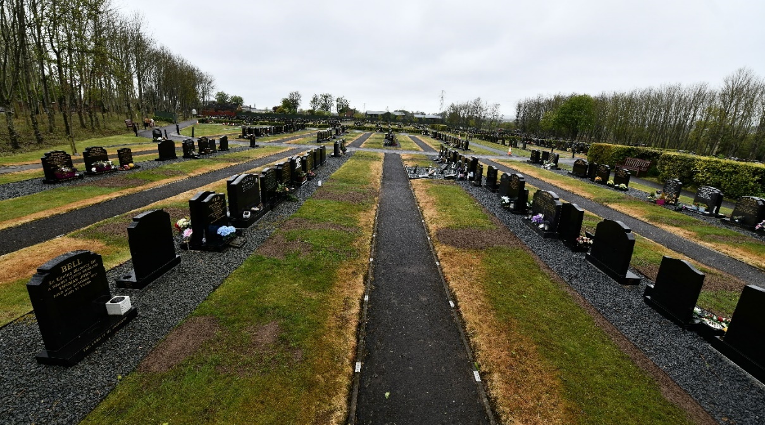

5.6 The Council understands that there remains a significant preference for traditional interment in a graveyard. The choice and access to cremation services has been limited for a number of reasons and should this change, the Strategy should take account of this. The proposals to develop Roselawn and increase access and availability to cremation services is kept under review and considered as part of the Strategy.

5.7 There are a number of denominations across the Council boundary which have their own burial ground space.

1. **Cemetery Rules and Regulations**

6.1 The Cemetery Rules and Regulations are an integral part of this Strategy and the basis for the management of the cemeteries.

6.2 They enable the public, funeral directors and memorial masons to understand the rules that the Council applies within all Council Cemeteries. In addition, Council Officers follow these rules and regulations to ensure the cemeteries are managed and operated in a common sense, practical and sympathetic manner. This also ensures consistency across the Council area.

The particular elements covered within the Rules and Regulations are:

1. General Information/details on the cemeteries;
2. Definitions;
3. Interment Details;
4. Funeral Director Information;
5. Memorial Mason Information;
6. Scale of Charges;
7. Manual Handling Procedure for handling coffin weights.

6.3 The current approved Cemetery Rules and Regulations can be viewed at the link below. The Rules and Regulations are reviewed annually or more frequently if changes to procedures occur. Any amendments/changes are updated and relevant service users are informed.

<https://www.lisburncastlereagh.gov.uk/uploads/files/Procedures_for_Interments_Associated_Monumental_Works_Rules_Regs_Sept_21.pdf>

6.4 Lisburn New Cemetery Extension is the only lawn cemetery within the Council area and as a result, only a headstone memorial is permitted. However, LCCC recognises that a number of plots have historically not adhered to the Council Cemetery Rules and Regulations whilst under the management of the former Council. Such non-compliant graves with historical breaches (over a certain period) cannot now be forced to comply with LCCC Rules and Regulations. However, any further non-compliance with Cemetery Rules and Regulations will be addressed in the most appropriate manner.

6.5 Resident and Non-Resident

6.5.1 A resident is defined as a person living within the Lisburn & Castlereagh City Council area at the time of death. Proof of residency will be required when confirming a burial application.

6.5.2 Former Lisburn & Castlereagh City Council residents who have had to move to a care facility outside of the Council area, will be considered a resident if they have not been living in the care facility any longer than 10 years from when they last lived in the LCCC area. Proof of residency will be required to determine residency.

6.5.3 A non-resident is a person who lives outside of the Lisburn & Castlereagh City Council area at the time of death.

6.6 Cemetery Fees and Charges

6.6.1 Fees and charges are reviewed and set annually and linked to the need for investment in our cemeteries to meet the needs of our bereaved and wider community.

6.6.2 All fees and charges will be determined by balancing what is a reasonable cost and the cost of managing and operating the cemeteries.

6.7 Subsidy Scheme for LCCC Residents

6.7.1 The Council will provide quality cemeteries with places for quiet reflection and where people can be remembered. The additional investment required to facilitate good design will be accommodated in the pricing structure.

6.7.2 Lisburn & Castlereagh City Council residents requesting to be interred in Belfast City Council Cemeteries Roselawn, Knockbreda or Dundonald, can apply to LCCC Cemeteries Office for a subsidy towards the burial costs. LCCC will review this subsidy as part of the annual rates setting process and in consultation with our neighbouring Councils as part of a general duty to co-operate.

6.8 Insurance

6.8.1 The Council will request a copy of Insurance details from Funeral Directors and Memorial Masons conducting activity within Council Cemeteries. There is a requirement to provide evidence of £5 million for Public and £10 million for Employers’ Liability.

6.8.2 If the Service User does not provide the appropriate level of insurance, the Council reserves the right to prohibit work or prohibit them from carrying out any work.

**7.0 Data Management**

* 1. The Council has a legal obligation under the Burial Regulations (Northern Ireland) 1992 to manage burial records. This has been managed through hardcopy record keeping. However, in 2005 the Council introduced an electronic management system, Cemetery Pro, to manage records within two of the Council’s main cemeteries.
  2. The Council has now introduced a new Management Information System. The system is known as Plotbox, which is a world renowned cloud based bereavement services management system. This will ensure that all Council cemeteries are managed through an electronic means.
  3. Bereavement data is therefore stored on a cloud based system offering additional security of information. The system also allows Funeral Directors access to a 24-hour online booking portal.

**8.0 Burials and Graves**

8.1 It is appreciated that the appearance of cemeteries can be enhanced by well maintained and presentable graves which are in keeping with a peaceful, tranquil and pleasant environment. The Council wishes to promote a good standard of ground maintenance. This complements the Cemeteries Rules and Regulations and the Council tries to maintain the highest standards within their cemeteries.

8.2 Since March 2005, grave plots can no longer be purchased in advance and are only permitted for purchase at time of death.

8.3 The Council understands families may not want a traditional type coffin/burial and therefore will try to accommodate sustainable burials which include environmentally friendly coffins, such as wicker or cardboard.

8.4 The Council is aware of the current burial capacity and therefore has taken the decision to utilise/maximise its current burial capacity by introducing an integrated cemetery. Historically, the Council had separate sections within their cemeteries for the two main religious faiths in Northern Ireland, Protestant and Roman Catholic. Since, March 2020 the Council has adopted an approach of integrated burials, i.e. no further segregation of any faiths.

8.5 The Council accommodates all ethnic groupings and religious faiths such as Chinese, Irish Traveller, Jewish and Muslim. However, it should be noted that the number of ethnic minority burials which has taken place within the Council cemeteries to date is very low. The Council is mindful of the current burial capacity available and therefore is not implementing separate burial areas for different religions at this time. As part of the equality screening process for the strategy, all S.75 groups will be considered and the Council will try to meet all religious beliefs, faiths or cultures.

**Ethnic Groups in LCCC (Local Government District 2014 based on 2011 Census)**

|  |  |  |
| --- | --- | --- |
| **Ethnic Group** | **Number** | **%** |
| White | 131623 | 97.61 |
| Chinese | 692 | 0.51 |
| Indian | 659 | 0.49 |
| Other Asian | 637 | 0.47 |
| Mixed | 558 | 0.41 |
| Black African | 209 | 0.15 |
| Other | 197 | 0.15 |
| Pakistani | 113 | 0.08 |
| Black Other | 58 | 0.04 |
| Bangladeshi | 37 | 0.03 |
| Irish Traveller | 35 | 0.03 |
| Caribbean | 23 | 0.02 |

8.6 Excess Death Emergency Plans

Cemetery provision is identified as a critical service within the Council’s Emergency Plan. Therefore, the Council has a contingency plan in place to manage a high demand for burial space due to an adverse event of mass death such as a pandemic. The Council will work with other neighbouring Councils and the Department of Justice of the Northern Ireland Executive to manage such an unfortunate incident.

8.7 Welfare Burials

8.7.1 If someone dies without enough money to pay for a funeral and no one to take responsibility for it, the local authority must bury or cremate them. It's called a 'public health funeral' and includes a coffin and a funeral director to transport them to the crematorium or cemetery.

8.7.2 The Council treats welfare burials with the greatest of dignity, sympathy and respect as it does for all other categories of burials. The Council’s first position is to cremate the deceased, unless information can be provided requesting a traditional burial.

8.7.3 Welfare burials will be provided in an un-purchased or public graves area within Lisburn Cemetery. Space for further burials cannot be reserved in these public graves and the erection of any memorial is not permitted.

8.8 Exhumations

8.8.1 An Exhumation can be carried out depending on the circumstances and as a last resort. An application form must be completed which is available from the Department for Communities (DfC) website. This is required to be completed by the applicant and then sent to the Council for consideration. The document is then sent to DfC for permission. There must be a valid reason for exhuming a body and these can be discussed with the Cemetery Office.

8.8.2 The Council will liaise with all relevant bodies if permission is granted by DfC. Exhumations are a high risk activity. The Council will conduct the exhumation with the utmost respect, dignity and sensitivity.

8.8.3 The cost of an exhumation is detailed within the Cemeteries Charging Scheme and is reviewed annually.

**9.0 Health and Safety**

9.1 Health and Safety is taken seriously by the Council and through its own internal procedures and risk assessments, it aims to minimise the risk to staff and visitors as far as reasonably practicable. The Council also updates/reviews the Cemetery Rules and Regulations regularly to ensure the safety of everyone involved in the cemeteries, including visitors, Funeral Directors and Monumental Sculptors.

9.2 Risk Assessments are carried out regularly to identify hazards and ensure the appropriate controls are in place to minimise the risk associated with the tasks/activities.

9.3 Cemetery staff are fully aware of the likely risks and are trained in safety awareness. Staff are supplied with the appropriate equipment to carry out the functions of their roles safely. Staff are adequately supervised/managed and any non-compliance with safety procedures will be fully investigated.

**10.0 Testing of Memorials and Headstones**

The Council recognises the significant risks associated with unsafe monumental memorials. The Council will implement appropriate procedures so as to ensure site safety across all cemeteries. The Council is a member of The National Association of Memorial Masons (NAMM), who will provide expert advice, guidance, training and support relating to memorial matters.

**11.0 Maintenance**

11.1 The Council has almost 47 acres (approximately 19 hectares) of cemetery land across the Council area to manage. It is recognised that the appearance of the cemeteries is enhanced by well-kept and presentable graves.

11.2 Maintenance of the cemeteries is provided by the Parks and Amenities Service Unit within the Council. Cemetery staff are a specialist team due to the nature of the work activities such as grave digging and dealing with grieving families. The team is responsible for the maintenance of all the Council operated cemeteries.

Duties included within this role are:

1. Digging graves;
2. Assisting interments;
3. Cutting graves;
4. Weeding and spraying;
5. Topping up of graves;
6. Cleaning and tidying up;
7. Inspection of approved Memorial works;
8. Testing of Memorials and Headstones.

11.3 Lisburn New Cemetery Extension was designated as a lawn cemetery when it opened in November 1997. In 2018 the Council installed stone strips within the Cemetery, where memorial headstones are placed. This was introduced to provide an area for memorial items/flowers to be placed and aid the efficient maintenance of the graves.

11.4 As time passes, graves inevitably are prone to a degree of subsidence. In an effort to maintain presentational standards, ensure hazard free maintenance and provide safe access for visitors, staff will level graves with the addition of soil and sow grass seed. This work does not interfere with the integrity of the grave itself.

11.5 The Council understands that any issue with regard to the grave of a loved one is a sensitive matter, and consequently welcomes any engagement to discuss concerns to address or alleviate any problems.

**12.0 Consultation and Liaison**

12.1 Lisburn & Castlereagh City Council fully appreciates the need and importance of consultation with Service Users, namely Funeral Directors and Monumental Sculptors. The Council has previously met with these service users to consider any relevant concerns/issues relating to the Cemeteries. The Council recognises the need to engage/consult with the service users on an annual basis.

12.2 Lisburn & Castlereagh City Council understands its duty under Section 75 of the Northern Ireland Act 1998. It aims to ensure that equality of opportunity and good relations are central to policy making and service delivery. The Council will also consult with the Public to hear their views relating to the Council Cemeteries.

**13.0 Lisburn & Castlereagh City Council Demands and Needs**

13.1 Projected Population Profile for LCCC 2018-2043:

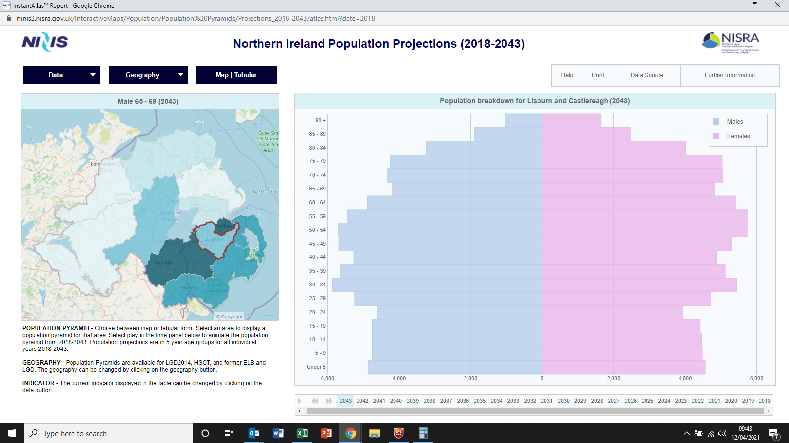

13.1.1 The chart above indicates projected population profile for LCCC area to 2043. The chart indicates a significant increase in the older population.

13.1.2 The following table outlines the population projections for the Lisburn Local Government District up to 2028 based on NISRA projections.



The table indicates:

* The overall population will increase from 141,181 in 2016 to 155,877 by 2028; a 10.4% increase.
* People aged over 60 are projected to increase from 31,510 in 2016 to 43,455 by 2028; an increase of 37.9%.
* The population projections for Lisburn Local Government District suggest that with an increase in the number of older people living in the area the death rate will continue to rise steadily over the next ten years. Therefore in principle, more cemetery provision will be required in the longer term in the District to address the needs up to 2032.
* Various factors can influence the population projections including, for example, net migration and changes in life expectancy e.g. due to advances in medicine etc.
* It is reasonable to assume that demand across the Council will be in the region of 128 traditional grave plots per annum, reflecting recent demand for burial plots. However, this assumption will only remain valid if:
* The population dynamics across the Council area remain largely neutral.
* The Northern Ireland approach to burial remains similar to the current position; i.e. there is a larger reliance on conventional grave plots than options such as cremation or woodland burial.
* Given the present pandemic this may require further statistical assessment in terms of having a greater impact on burial need.
* Other trends will need to be monitored to consider changes in societies such as move towards cremation rather than traditional burials and a retreat from church based community. These will have an impact on burial need.

13.2 Projected Population Growth to 2036

|  |  |  |  |  |  |
| --- | --- | --- | --- | --- | --- |
|  | 2019 | 2023 | 2027 | 2031 | 2036 |
| **Northern Ireland** | 1,888,100 | 1,919,300 | 1,945,700 | 1,966,200 | 1,986,200 |
| **Lisburn & Castlereagh** | 145,100 | 150,100 | 154,800 | 158,900 | 163,500 |

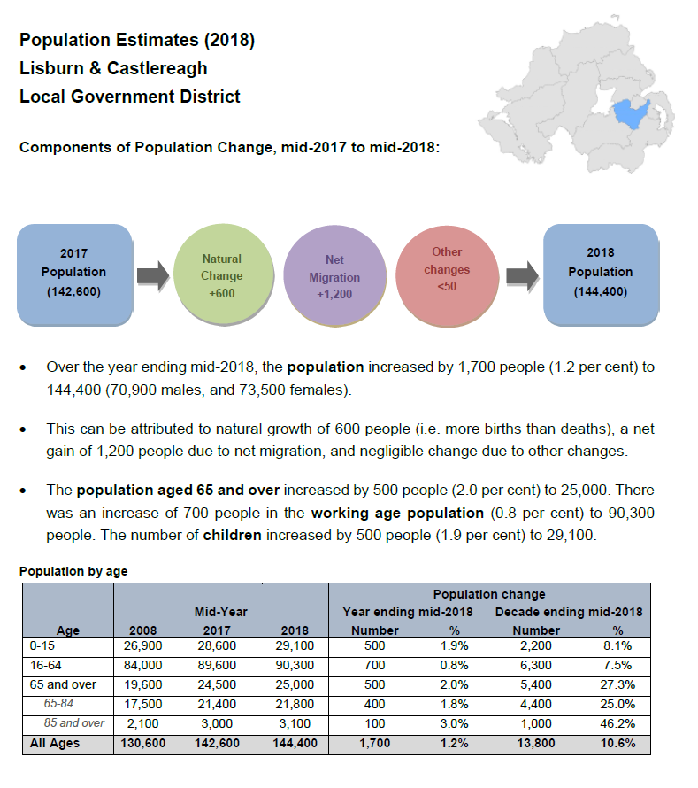

The Projected Population Growth identifies the projected growth of population to the year 2036. There is a significant projected increase in the 65+ population. It could be assumed that this will increase the need for further cemetery provision as there will be an older population and therefore more deaths. Population growth will have a bearing on deaths and this may lead to a need for further burial space.

13.3 Total Number of Grave Plots sold by LCCC 2015–2021

|  |  |
| --- | --- |
| **Financial Year** | **Total Number of New Grave Plots Sold** |
| 2015 – 2016 | 120 |
| 2016 – 2017 | 136 |
| 2017 – 2018 | 135 |
| 2018 – 2019 | 112 |
| 2019 – 2020 | 134 |
| 2020 – 2021 | 126 |

The total number of new grave plots sold by LCCC 2015-2021 has been fairly consistent over the years but as population rates increase, especially in the older population, there will be a need for more new burial plots.

13.4 Total Number of Deaths within the LCCC area

|  |  |
| --- | --- |
| **Year** | **Total Number of deaths in LCCC** |
| 2015 | 1140 |
| 2016 | 1167 |
| 2017 | 1200 |
| 2018 | 1164 |
| 2019 | 1236 |

The total number of deaths within the LCCC area has been fairly consistent over the years. However, given the present pandemic and an ageing population within the District, it can be assumed that the death rate is likely to increase.

13.5 Short Term Needs and Opportunities

The Council recognises that new burial plots are required in the short term. The Council is currently progressing short term measures to increase capacity at Lisburn New Cemetery Extension. Assuming the project delivers the anticipated increase in burial provision, this will provide an approx. 720 additional graves which will provide future burial capacity until circa. 2028 (7 years). This provision also includes a memorial/remembrance garden where ashes can be scattered. It is anticipated this project will be completed in 2024.

13.6 The Map below illustrates the proposed areas for extension within Lisburn New Cemetery extension.

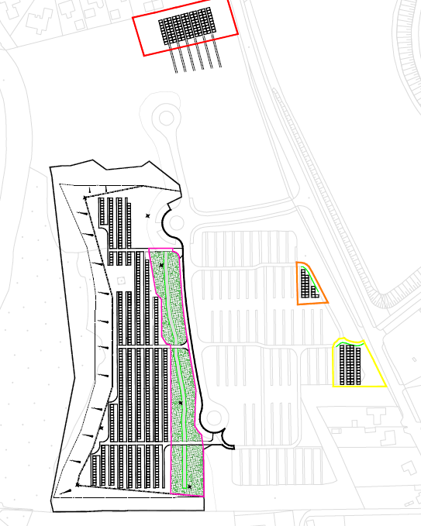

13.7 Long term Needs

13.7.1 Lisburn & Castlereagh City Council will experience an increase in demand for cemetery provision over the long term given the increase in the number of older people living in the area.

13.7.2 Northern Ireland is traditional in its approach to burials, with under 22% of deaths cremated in 2019. This is compared to England and Wales which has a cremation rate of 80% in 2019. Northern Ireland presently has only one Crematorium which is based within the LCCC area but owned by Belfast City Council. Belfast City Council have approval for increasing the capacity of their crematorium but work has yet to commence. Antrim & Newtownabbey Borough Council and Fermanagh and Omagh District Council both have planning permission for a crematorium but no indication as to when these will be progressed; therefore, it is recognised that traditional burial capacity is likely required, unless there is a significant change in tradition in Northern Ireland towards cremation rather than conventional burial. LCCC recognises the increasingly diverse society in which we live and the need to provide all religious faiths. The Council will consider the needs of all religious faiths and how they can be accommodated in future burial space.

13.7.3 It is approaching 25 years since Lisburn New Cemetery Extension was opened. The cemetery capacity is becoming limited and even with the planned extension, capacity is likely only available until about 2028, which provides 7 years additional capacity. Therefore, there is a need to consider the long term future of burial space for provision up to 2032 and beyond.

13.7.4 As part of the long term consideration for burial capacity, the Council recognises the growing diverse society we live in. As a result the will consider whether there is a need for segregated space for the different religious faiths.

13.8 Additional Provision

Planning Permission has been granted for a privately owned and operated cemetery at Lisburn Road, Moira, approximately 13 miles south of the proposed site. This site is located close to the M1 Motorway, just off the Moira roundabout. The understanding is that the facility would be owned, operated and maintained by the applicant. The planning permission has granted capacity for 8500 burial plots which also includes 2 crematoria. However, current legislation within Northern Ireland only permits a Local Authority to operate and maintain a crematorium. If the average figure of grave plot sales is used of 128 per annum (see para 5.3), this would provide 66 year supply.

13.9 Neighbouring Councils Engagement

Lisburn & Castlereagh City Council will collaborate where possible with neighbouring Councils so as to consider sub regional needs and opportunities. This engagement will continue to consider collaboration across the region. LCCC must however first assess and confirm local need and opportunity so as to progress any sub regional opportunities.

**14.0 Lisburn & Castlereagh City Council Conclusion on Needs**

14.1 Lisburn & Castlereagh City Council has considered the needs for short and long term cemetery provision. However, the Council recognises the need to consider a longer term strategy beyond the lifetime of the Local Development Plan 2032, which will need to consider moving trends within the demographics of the Council area and the shift to other options for burials.

14.2 In the short term the Council is in the process of progressing a phased extension to the Council’s existing Cemetery, Lisburn New Cemetery Extension. If this Planning Application is granted approval, the project should be completed by 2024 with circa. 750 additional plots which should provide enough burial space until 2028.

14.3 In the longer term, the Council recognises the need to process an Outline Business Case (OBC) for considering the need for additional longer term cemetery provision. This piece of work will also consider a need beyond the current Local Development Plan and Community Plan which is considered up to 2032. With the population increasing in the Lisburn & Castlereagh area, particularly within the older population, it can be assumed there is going to be a need for additional burial capacities. With this in mind, the Council needs to be aware of a shift/change in public attitudes towards other types of burials, especially as Northern Ireland has always been traditional in its approach to burials. As part of this longer term consideration of need the Council will collaborate with other Councils to review the need on burial capacities both locally and regionally and consider a Cemetery feasibility study along the Blaris Road corridor. The Council will also explore the opportunities that may be available at the Lisburn Road, Moira cemetery. With Planning Approval already granted, this may provide the necessary additional burial capacity required by the Council.