

**Expression of Interest for the Provision of**

**Project based learning opportunities**

**at Navigation House**

**148 Hillsborough Road, Lisburn**



Lisburn and Castlereagh City Council is seeking Expressions of Interest from a third party or parties for the lease of Navigation House.

The building has recently been refurbished to create a versatile and adaptable space in a prime location which will facilitate the delivery of innovative and creative projects being delivered on site. These projects could be a mix of social economy and/or appropriate commercial projects.

In order to understand the facilities available a site visit should be arranged to view the space prior to the submission of an Expression of Interest *(contact details to arrange a site visit at the end of the EOI form).*

The information gained from this exercise will be used by the Council to decide how it will let the site. The Council is committed to supporting initiatives that can provide a positive social and economic impact, and with this in mind are open to social enterprise organisations and collaborations between providers.

It is the Councils preference to lease the site to one tenant, or to a consortium of tenants led by one tenant, offering the delivery of an integrated complementary programme of activity. The lead or single tenant will be responsible for key holding, and inspection and maintenance of the site and building

The Council anticipates achieving a fair market rental for the property, a recent valuation of the site indicates an annual rental value in the region of £18,000. The annual rental value does not include rates, utility site inspection or maintenance costs. The Councils preference is to lease the building under a full repairing and insuring lease. Alternatively the Council may consider a rental lease with the additional costs for associated building utility, building inspection and maintenance costs recovered as an annual service charge. The operating organisation will be responsible for the payment of Rates.

It is proposed that the lease be for a period of five years with an option to extend for a further 5 years. The lease will include restrictive clauses with regard to advertising and promotion on site.

The Council will reserve the right to designate in default, as part of the wider site, in negotiations with the prospective leasee, commercial tenancy’s in line with the original business case and in support of the Lagan Navigation theme and Lagan tow path. These may be community based projects with protected rights of access and egress.

**Location and Venue**

Navigation House is situated at 148 Hillsborough Road on the western outskirts of Lisburn close to the Blaris Road junction and Motorway links at Sprucefield roundabout. Navigation House, the former residence of the Canal Manager of the Navigation, has been recently refurbished to restore the building to its former glory. The building built c1866 has benefited from a million pound investment programme which has seen the restoration of the house and associated stable block and courtyard to create a multi-purpose facility. The property is approximately one mile from Lisburn City Centre. The site is bound by neighbouring residential building to the north and south whilst the River Lagan runs close to the western boundary.

The main house is a former dwelling of B1 listed status converted to office accommodation which has been refurbished and extended into a former stable block to provide workshop, exhibition space, stores and a first floor classroom. The refurbishment is of a very high standard with a lift installed to provide disabled access to the first floor extension. A glass greenhouse has also been erected to the side of the building.

**Property details**

The newly refurbished building offers the following facilities;

* Potential office space (6 rooms available ground floor/first floor)
* Breakout space/ exhibition space in the former Courtyard.
* The exhibition space is covered with a flat sedum roof with glazed curtain walling (aluminium frame) below allowing natural light into the internal parts;
* workshop facilities on the ground floor
* Stables have been developed into a meeting room and further workshop/classroom space to offer community and training facilities.
* The upper floor is accessible via stairwell and platform lift.
* Small kitchen facility which reflects the period of the house
* accessible W/C at ground floor
* Extension to the rear of the stable block containing stores and an accessible W/C;
* Glass covered greenhouse to the southern elevation of the House with elevated gardens that could be used, for example, as a herb garden.
* Substantial grounds surrounding the building are also available for a range of options. For example, one option could be to create allotments and vegetable/herb gardens to support delivery of sustainable eating and horticulture programmes.

**Floor plans**

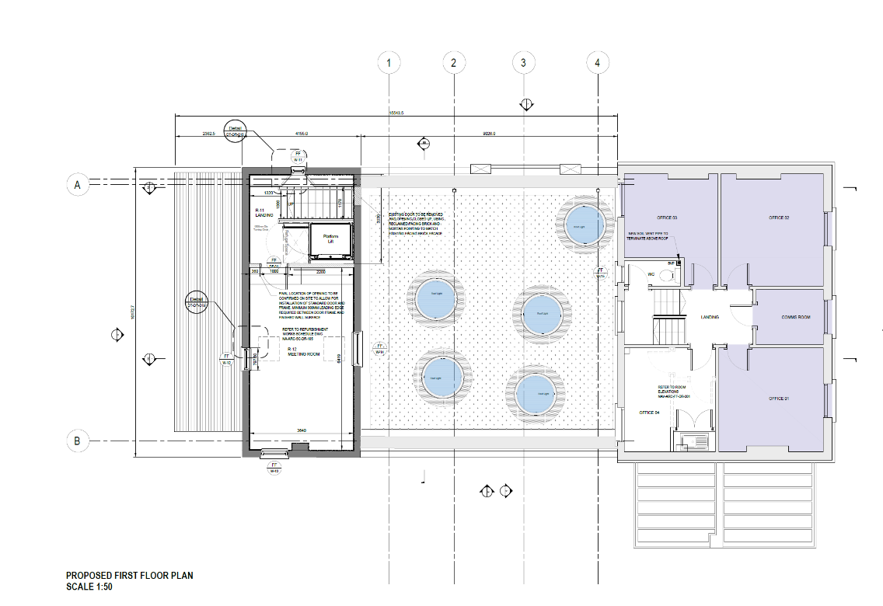

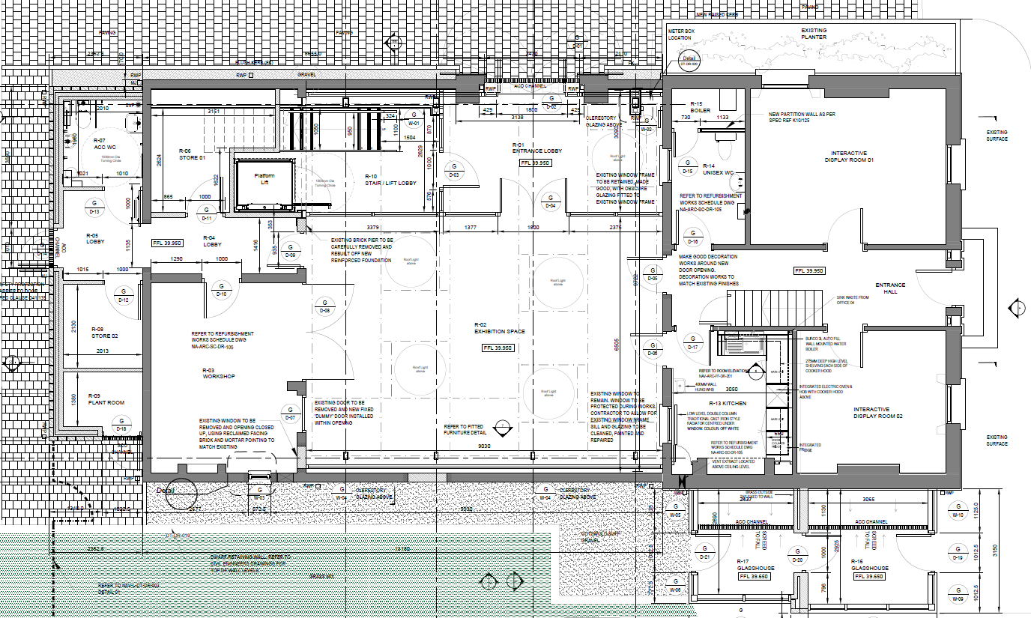

**Site Plans**

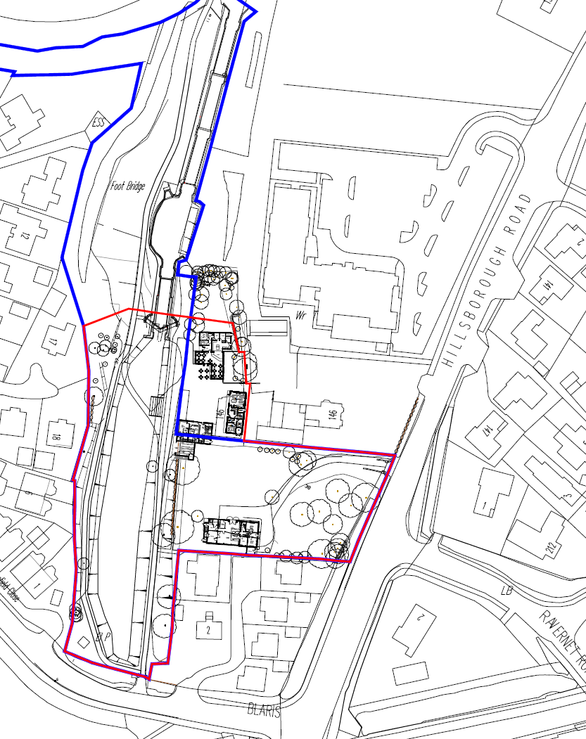

**Area for lease shaded in blue**

**Project Objectives**

* to protect the heritage of the listed buildings whilst creating a new space to facilitate the delivery of initiatives to complement the importance of the Lagan Navigation and waterways to the surrounding area.
* to provide space to accommodate the delivery of programmes that focus on skills development, employment, learning, volunteering, and outreach in the heritage and environmental management sectors in relation to waterways, the Lagan canal and its surrounding communities.

Third parties must outline proposals that meet the objectives outlined above.

**Opportunities for Businesses/ Social Enterprises**

There is an opportunity for businesses and social enterprises across the Council area to avail of the added benefits that this project would offer, allowing them to extend their ability to deliver their outcomes.

The site would support a wide range of profit and not for profit business models from catering opportunities, bike hire, allotments, conference hire, exhibition space and much more.

Navigation House has also the potential to work as a social enterprise hub with a number of organisations working on social, environmental or economic impact issues, as well as the possibility of working in collaboration to deliver initiatives that will have a greater impact across the Council Area.

Additionally the potential exists to collaborate with similar organisations to develop the delivery of programmes/ training/workshops that focus on complementary topics which should include;

- Biodiversity

- Gardening Skills & Plant propagation

- Horticulture

- Rewilding

- Starting your own sustainable Business

- Cookery and healthy eating

**Opportunities for Programme Delivery**

There is an opportunity to;

* Deliver a range of accredited project-based learning and employability courses such as the SQA Personal Development Award and the John Muir Award, as well as Waterways first aid and Waterways safety training.
* Provide non-accredited courses, including masonry and horticulture with the primary target group being young people (aged 16–30) with low educational attainment, particularly those in the youth justice system, looked after children’ and unemployed.
* Develop programmes that target adults that face barriers to entering the workforce due to, for example, challenges of ill health or lacking in social skills.

**Queries**

Please contact Yvonne Burke, Regeneration Manager (acting) on **07500 032023** if you have any questions.

**Closing Date**

Expressions of interest should be completed and returned to [becky.gamble@lisburncastlereagh.gov.uk](mailto:becky.gamble@lisburncastlereagh.gov.uk) by 5 pm Monday 26th October 2021.

**Guidance on how to complete the form and how the received Expressions of Interest will be assessed**

The Council is seeking expressions of interest from organisations with innovative ideas on how best to utilise the newly created space. We welcome submissions that can see an opportunity for delivering initiatives on the site and can use this space for the wider Lisburn and Castlereagh community benefit.

Applicants should consider both the Council’s Corporate plan and Community plan and should demonstrate how their proposal meets the objectives of both plans when detailing the wider community need.

[Corporate Plan 2018 click here](http://www.lisburncastlereagh.gov.uk/uploads/general/CORPORATE_PLAN_2018.pdf)

[Community Plan, click here](https://www.lisburncastlereagh.gov.uk/resident/community-planning)

Applicants should note that the Council will not be providing any additional revenue funding.

All sections of the form must be complete and returned by the specified deadline. Any applications returned after the specified deadline or not fully completed will eliminate the submission from the process.

The Council reserves the right to enter into negotiations with the successful third party or parties before deciding on its preferred course of action.

Submitted Expressions of Interest will be assessed by the Council against the following criteria;

|  |  |
| --- | --- |
| **Criteria** | **Maximum score** |
| How the proposal meets the Project Objectives as outlined above | 20 |
| Capacity to deliver | 20 |
| Evidence to support the sustainability of your organisation | 20 |
| Clear needs based on rational proposed | 10 |
| Linkages to the Council’s Corporate Plan and Community Plan | 10 |
| Experience of working projects similar to what is proposed to be delivered at Navigation House | 10 |
| Ability to monitor and ensure minimum quality | 5 |
| Experience of partnership working | 5 |
| **Total** | **100** |

* Please note the panels decision is final and there will be no appeal process
* Submissions achieving a score of over 70 will be invited to submit a business case
* A maximum of three sides of A4 in additional information or evidence will be accepted with expression of interest forms.

**Closing Date**

Expressions of interest should be completed and returned to [becky.gamble@lisburncastlereagh.gov.uk](mailto:becky.gamble@lisburncastlereagh.gov.uk) by 5 pm Monday 26th October 2021.

**Application Form.**

Name of Business/ Social Enterprise: _________________________________________________ Address: _________________________________________________ Contact: _________________________________________________ Contact Details: _________________________________________________

1. Please provide a brief description of what you propose to deliver at Navigation House:
2. Please indicate how this proposal links to Lisburn and Castlereagh City Council’s Corporate Plan:
3. Please indicate how this proposal links to Lisburn and Castlereagh City Council’s Community Plan:
4. Please provide a brief description as to how this proposal will benefit the Lisburn and Castlereagh community in terms of project outputs and outcomes, including any Key Performance Indicators:
5. Please provide a brief description as to how this proposal is needs based:

**Pricing**

Please complete the table below detailing your proposed annual rental value to be paid to the council. Please provide a detailed explanation to support your proposal outlining the benefits your project will bring to the area, offering value for money socially and economically, and how this is reflected in your proposed annual rental value.

|  |  |
| --- | --- |
| **Proposed annual rental value** | **£** |
| **Supporting statement;** |  |

* It is recommended that you avail of a site visit prior to submitting your expression of interest; please contact Becky Gamble via email at [becky.gamble@lisburncastlereagh.gov.uk](mailto:becky.gamble@lisburncastlereagh.gov.uk) or contact **07500 032023** to arrange an appointment.
* Once all of the applications have been assessed, an invitation will be issued to the successful applicants to submit a full business case.