

**URBAN INVESTMENT FUND  
Expression of Interest (3rd Call, Amended)**

**Guidance Notes and Application Form**

**Supporting Business Growth and rationalising vacancy in the URBAN CentreS**

**The Aim**

Lisburn and Castlereagh City Council has launched a third call for the URBAN INVESTMENT FUND which will support the economic growth and resilience of the urban centres of Lisburn, Dundonald and Carryduff through the provision of grants for interior and exterior improvements to commercial buildings, expansions or repurposing of premises.

In this 3rd call, Grant aid will be prioritised to encourage new business into the Urban Centres, particularly focusing on Fashion Retail. We are welcoming new businesses that are currently not represented in our urban centres or business that will help to support the night time economy.

We will again support existing businesses to diversify their current offer through repurposing of vacant units (to include unused areas of their current premises).

The aim of the Urban Investment Fund is to:

1. Improve the offer in the urban centres of Lisburn, Dundonald and Carryduff by reducing the current vacancy rates and attracting new businesses into the centre
2. Decrease the number of vacant units in the Urban Centres by offering financial assistance to existing businesses to offset capital costs or repurpose their existing business premises.
3. Decrease the number of vacant units in the Urban Centres by offering financial assistance to new businesses who wish to occupy a vacant property.

**The Package**

The funding pot is currently £100,000 and allocation will be subject to change based on the number of eligible applications received. Successful businesses will be required to match fund 10% of the total costs including any VAT or Legal Fees incurred.

Funding is allocated based on business footprint. The following 3 packages are available;

1. For Businesses with a footprint of less than 100 Square Metres the grant will be **up to** £7,500, which the business must match fund by 10%. This measurement does not include storerooms, kitchens or bathrooms.

2. For Businesses with a footprint of between 100 and 150 Square Metres the grant will be **up to** £15,000, which the business must match fund by 10%. This measurement does not include storerooms, kitchens or bathrooms**.**

3. For Businesses with a footprint of 151 Square Metres and over the grant will be **up to** £25,000, which the business must match fund by 10%. This measurement does not include storerooms, kitchens or bathrooms.

Preference will be given to business with on-street frontage.

**GUIDANCE NOTES**

**Please note; the scheme is a two stage process. This first stage is an expression of interest which will be used to shape and inform the scheme and understand the need of the businesses. Following the completion of expressions of interest successful applicants will be invited to full application stage.**

**APPLICATION PROCESS**

The scheme will assist new businesses who are interested in setting up in the urban centres and existing businesses who wish to repurpose their premises or part thereof to adapt their business.

It is important that improvements carried out within this scheme are appropriate to the character of the urban area they sit within and a high standard of materials and workmanship are used.

*Please Note: Businesses located or wishing to locate in the Conservation area must liaise directly with the planning Conservation Offer in order to ensure adherence to Conservation Guidelines.*

Applications will be assessed in two stages as follows:

1. Expressions of Interest
2. Grant Application

**Who can apply?**

The scheme will assist new businesses, ideally, in Fashion Retail or a unique business to the urban centre`s wishing to renovate a vacant property; or an existing business planning to diversify their current offer through repurposing an unused area within their premises.

Business owners must show a holding a lease of a minimum of three years or proof of ownership.  
  
Please note; Grants will not be awarded to business who are closing an existing unit to open in an alternative premises.

Applications will be assessed as a grant to the proprietor of the business.

If demand exceeds the amount of funding that is available, priority will be given to businesses which provide a different or ‘enhanced’ offer; are likely to create more jobs and footfall; will be part of the evening economy.

**APPLICANT ELIGIBILITY**

The scheme allows potential new businesses to apply for an improvement grant to renovate vacant units and allows existing businesses who wish to repurpose and diversify their business or part thereof. Properties must be located within the defined urban centre boundaries to include Dundonald and Carryduff. Please refer to the boundary maps located in Appendix 1.

Eligible applicants will

* Occupy vacant properties
* Repurpose existing properties or part thereof
* Improve the City and Urban Centres and complement what is currently on offer
* Demonstrate how repurposing existing businesses will benefit the Urban Centres and the business.
* Create a viable and sustainable business investment opportunity
* Demonstrate value for money will be achieved in the cost of the works
* Applications are limited to one per property
* A minimum 3 year lease is required
* Preference will be given to business with on-street frontage
* Preference will be given to evening economy businesses
* Preference will be given to `unique` businesses

**Applicants who were not successful in the first and second call of this scheme are not eligible to re-apply.**

Award of the grants will be at the Councils discretion.

The Council will have the ultimate decision in determining the types of business that are eligible for grant funding assistance. This will be assessed on a case by case basis.

Whilst we recognise that all business types have their place on the high street, over concentration of certain types of shops make the centres less appealing to both visitors and investors. This scheme is to encourage new business types and activities which will improve the perception of the area and increase footfall.

**Non eligible businesses include (but are not limited to);**

* Pay day loan shops
* Betting/ gambling shops
* Charity shops
* Pawn shops
* Vape shops
* Adult shops
* Budget/Pound shops
* Temporary shops

**grant Amounts**

Funding allocated will be based on the number of businesses invited to full application and will depend on each business case. Successful businesses will be required to match fund 10% of the total costs including any VAT or Legal Fees incurred.

**What can the Grant pay for?**

**Minimum consideration for funding**

Works to frontage of the unit(s), interior refurbishment works and/or utilising previous unused space to repurpose the business i.e. a second or third floor space.

**ELIGIBLE COSTS**

* Improvement works to vacant unit(s) which are required to improve the building and allow a business to commence trading.
* Replacement of doors/ windows/flooring, electrical works, plumbing works, minor construction works such as knocking down walls/ roof repairs etc. i.e. any works required to allow a business to commence/continue trading may be considered.
* Internal modifications to vacant properties which includes shop fit-out, subdivision of, internal decorations, flooring, mechanical and electrical works with a view to improving the vacant property (works must be approved by property owner)
* External Facades and Signage
* Maintenance works to include removal of redundant signage, cleaning (power washing), clearing of debris and repairs of decorative features.

**INELIGIBLE COSTS**

* Any costs or projects which are clearly another statutory agency’s responsibility
* Insurance costs
* Interest / banking fees
* Rates
* Projects situated outside the Lisburn and Castlereagh Urban Centres as denoted by BMAP. Please refer to the boundary maps located in Appendix 1.
* Costs incurred prior to a letter of offer from Council (retrospective funding)
* Costs which are not clearly linked to the project
* Costs that are assessed as poor value for money, or that are purchased not following Council procurement guidelines
* Costs that are already covered by other funding or income sources
* VAT related cost
* Planning, Legal costs
* Costs which are deemed excessive by Council’s QS Team
* Cash expenditure will not be eligible for refund from Council

Please note:

Any significant alterations to the works that were agreed at application stage must be approved by the Council in advance as still being eligible for funding.

**PROCUREMENT:**

Evidence must be made available to demonstrate that that the applicant has endeavoured to obtain quotations for each element of the works provided from a reputable supplier. Whilst preferably all quotes are to be submitted as part of the grant application, please see the quotation thresholds below, Council do understand that they can be difficult to obtain at this stage but applicants please note that all quotes must be in place before any grant payments can be made. Grant funding will not be paid out on work that has been carried out without receiving a quotation unless it has been previously agreed with the council.

|  |  |
| --- | --- |
| **Expenditure** | **No of quotations** |
| Up to £500 | 2 verbal quotations |
| £501 - £3,000 | 2-3 companies should be contacted by email to show that value for money has been sought |
| £3,001 - £15,000 | 3 written quotations required |
| £5,001 - £30,000 | 4 written quotations required |

**WHAT STATUTORY AND LEGAL CONSENTS DO I NEED?   
  
Planning Application**

Planning permission will be required for works being undertaken within the Conservation Area which involves a material change to the appearance of the building, such as shop fronts and signage, awnings and shutters. When a property has listed status, such works will also require listed building consent.

**Advertisement Consent for Signage**

In addition to a planning application, all types of signage such as fascia or hanging signs will require a separate application for Consent to Display and Advertisement. Within the Conservation Area proliferation of signage is to be avoided and should be both minimal and discreet. Information on the sign should state only the name, trade and street number.

All statutory and legal consents must be in place before the grant payment can be made. Please see relevant contacts below;

Planning, for more information email: [planning@lisburncastlereagh.gov.uk](mailto:planning@lisburncastlereagh.gov.uk)

Building regulations, for more information email: [building.control@lisburncastlereagh.gov.uk](mailto:building.control@lisburncastlereagh.gov.uk)

Food premises registration [Food Premises Registration Form](https://register.food.gov.uk/new/lisburn-and-castlereagh) (where applicable).

If a business receiving grant funding is later held to account for any breaches relating to those improvements, the funding can be held back or if paid then claimed back from the recipient.   
  
Please see below a map of Lisburn City Centre with the conservation area highlighted;

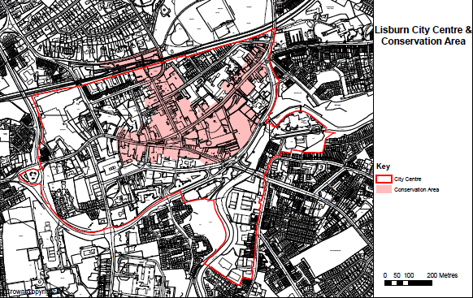

**Stage 1 – Expressions of Interest Call**

This open call is available to new businesses or existing businesses repurposing their offer.

The following basic eligibility criteria applies and will be assessed on a pass/fail basis as part of the evaluation process:

1. The property must be located in Lisburn City Centre or the Urban Centres of Carryduff or Dundonald
2. The property must be vacant or being repurposed by an existing business
3. The Business must have a minimum of three years remaining on their Lease
4. Expressions of Interest to be received no later than Friday 2nd December 2022

* **Stage 2 – Application**

In order to progress this stage, the applicant will be required to provide further details of the proposed works.

Full application will include the provision of:

1. Confirmation of engagement with competent architect (*Contact details must be provided)*
2. An outline project plan providing detailed information about the project/concept design *(please provide images / drawings separately)*
3. Written quotations for proposed works demonstrating value for money has been achieved *(see procurement section for details)*
4. Written confirmation from the local planning department that details all necessary statutory consents required to carry out your project *(including but not limited to: planning permission, advertising consent, listed building consent, building control consent, change of use etc.)*
5. Confirmation that 10% match funding in place with the applicant
6. Evidence of security of tenure and written consent from property owner

If your application is successful, confirmation will be sent via email, detailing the amount of grant you are eligible for and match funding required. Your letter of offer will be issued to you upon receipt of your planning reference number.

**Deadline for Applications – Monday, 23rd January 2023 at 12 noon**

* **Stage 3 – Letter of Offer**

A letter of offer will be provided via email, detailing the amount of grant awarded, on provision of the following:

* Architectural drawings of the proposed works submitted to planning and planning reference number provided. Drawings should be shown to scale e.g. 1:100. *To ensure clarity of shop front detail, include elevation drawings at a scale of 1:20 and section drawings at 1:10 as appropriate.*

**Final Deadline for Planning Submission & Reference Number – Monday, 20th March at 12 noon 2023**

**We understand that this process can be lengthy so please allow for time to consult with planning and provide final drawings in order to secure planning approval.**

**Expression of interest**

1. **APPLICANT DETAILS**

NB: The applicant must be the key contact to discuss all details of this application

|  |  |  |  |  |
| --- | --- | --- | --- | --- |
| Full Name |  | | | |
| Address Line 1 |  | | | |
| Address Line 2 |  | | | |
| Address Line 3 |  | | | |
| County |  | | | |
| Post Code |  | | | |
| Tel No |  | |  | |
| Email address |  | | | |
| Relationship to Property (tick) | Owner | Tenant (How many years lease?) | | Other (Please State)  Currently in negotiations to secure the lease |

1. **PROPERTY OWNER DETAILS**

**Same as above**

|  |  |  |
| --- | --- | --- |
| Registered Property Owner Name |  | |
| Address Line 1 |  | |
| Address Line 2 |  | |
| Address Line 3 |  | |
| County |  | |
| Post Code |  | |
| Tel No | Landline: | Mobile: |
| Email address |  | |
|  | | |
| If there are multiple registered property owners, please provide all property owner details? | | |
| Property Owner Name |  | |
| Address Line 1 |  | |
| Address Line 2 |  | |
| Address Line 3 |  | |
| County |  | |
| Post Code |  | |
| Tel No | Landline: | Mobile: |
| Do you have other properties in the City Centre? | YES □ | NO □ |

*Additional owner details should be supplied in appendices to this application form.*

1. **BASIC ELIGIBILITY SELECTION**

|  |  |  |  |
| --- | --- | --- | --- |
| **3a** | Property Address Line 1 |  | |
| Property Address Line 2 |  | |
| Property Address Line 3 |  | |
| County |  | |
| Post Code |  | |
| **3b** | Is your vacant property or existing business located in Lisburn City Centre, Carryduff or Dundonald? | YES □ | NO □ |
| **3c** | If the property has been vacant. How long has this been for? | Vacant:  Time Vacant: | |

1. **PROPERTY BACKGROUND QUESTIONS (Please complete all questions)**

|  |  |  |  |
| --- | --- | --- | --- |
| **4a** | What was/is your building used for?  E.g. retail, offices, residential, industrial etc. | Basement |  |
| Ground Floor |  |
| 1st Floor |  |
| 2nd Floor |  |
| **4b** | Provide a detailed description of the ***external***condition of the property or the area earmarked for repurposing if this relates to your project.  *(Please attach supporting photographs)* |  | |
| **4c** | Provide a detailed description of the ***internal*** condition of the vacant property or the area earmarked for repurposing if this relates to your property.  *(Please attach supporting photographs)* |  | |
| **4d** | What is the nature of the proposed business? |  | |
| **4e** | Is the property completely vacant or partially vacant? Is the area to be repurposed currently unused? |  | |
| **4f** | What is the current annual rates for the property? (£) |  | |
| **4g** | What is the current NAV (non-domestic net annual value) for the property? |  | |
| **4h** | Is your property a listed building? | YES □ NO □ | |
| **4i** | Is your property in the Conservation Area of Lisburn City Centre? | YES □ NO □ | |
| **4j** | Is your property structurally safe to enter for assessment purposes? | YES □ NO □ | |

1. **PROPERTY PROJECT DETAIL**

|  |  |  |
| --- | --- | --- |
| **5a** | Please provide details of the proposed project.  *(Supporting information e.g. photographs, images, drawings, material specification)* | |
|  | | |
| **5b** | Does your project require statutory consent? | **Planning permission**  YES □ NO □  **Building Control**  YES □  NO □  **Listed Building Consent**  YES □ NO □ |
| **5c** | Have you lodged applications for any required consent? | **Planning permission**  YES □ NO □  **Building Control**  YES □ NO □  **Listed Building Consent**  YES □ NO □  *Please quote planning reference number:* |

1. **FINANCIAL DETAILS**

|  |  |  |  |
| --- | --- | --- | --- |
| **6a** | | Please detail anticipated budget/costs for the work listed above in 5a. Costs should be based on quotations received from reputable suppliers. | |
|  | | | |
| 6b | Please confirm the required 10% match funding is in place and confirm the source of the funding. | |  |

1. **APPLICATION PRE-REQUISITES**

|  |  |  |
| --- | --- | --- |
| I can confirm I will arrange access to the property in order to allow Council officers and the Quantity Surveyor to assess the property | **YES** | **NO** |

1. **DECLARATIONS**

I declare that the information given above is true and correct to the best of my knowledge.

I we understand that Council may ask for additional information at any stage of the process.

|  |  |  |
| --- | --- | --- |
| I confirm I have included internal and external photographs | **YES** |  |
| I confirm I have included supporting information for question 5a | **YES** |  |

|  |  |
| --- | --- |
| **Signed** |  |
| **Date** |  |

Please return the Expression of Interest form no later than Friday 2nd December 2022 at 12 Noon to Melanie Finn email: [Melanie.finn@lisburncastlereagh.gov.uk](mailto:Melanie.finn@lisburncastlereagh.gov.uk); or to 11-13 Market Square, Lisburn, BT28 1AE.  
Any queries or additional information please call Tel No 02892 447542.

**Appendix 1 – Carryduff Urban Boundary Map**

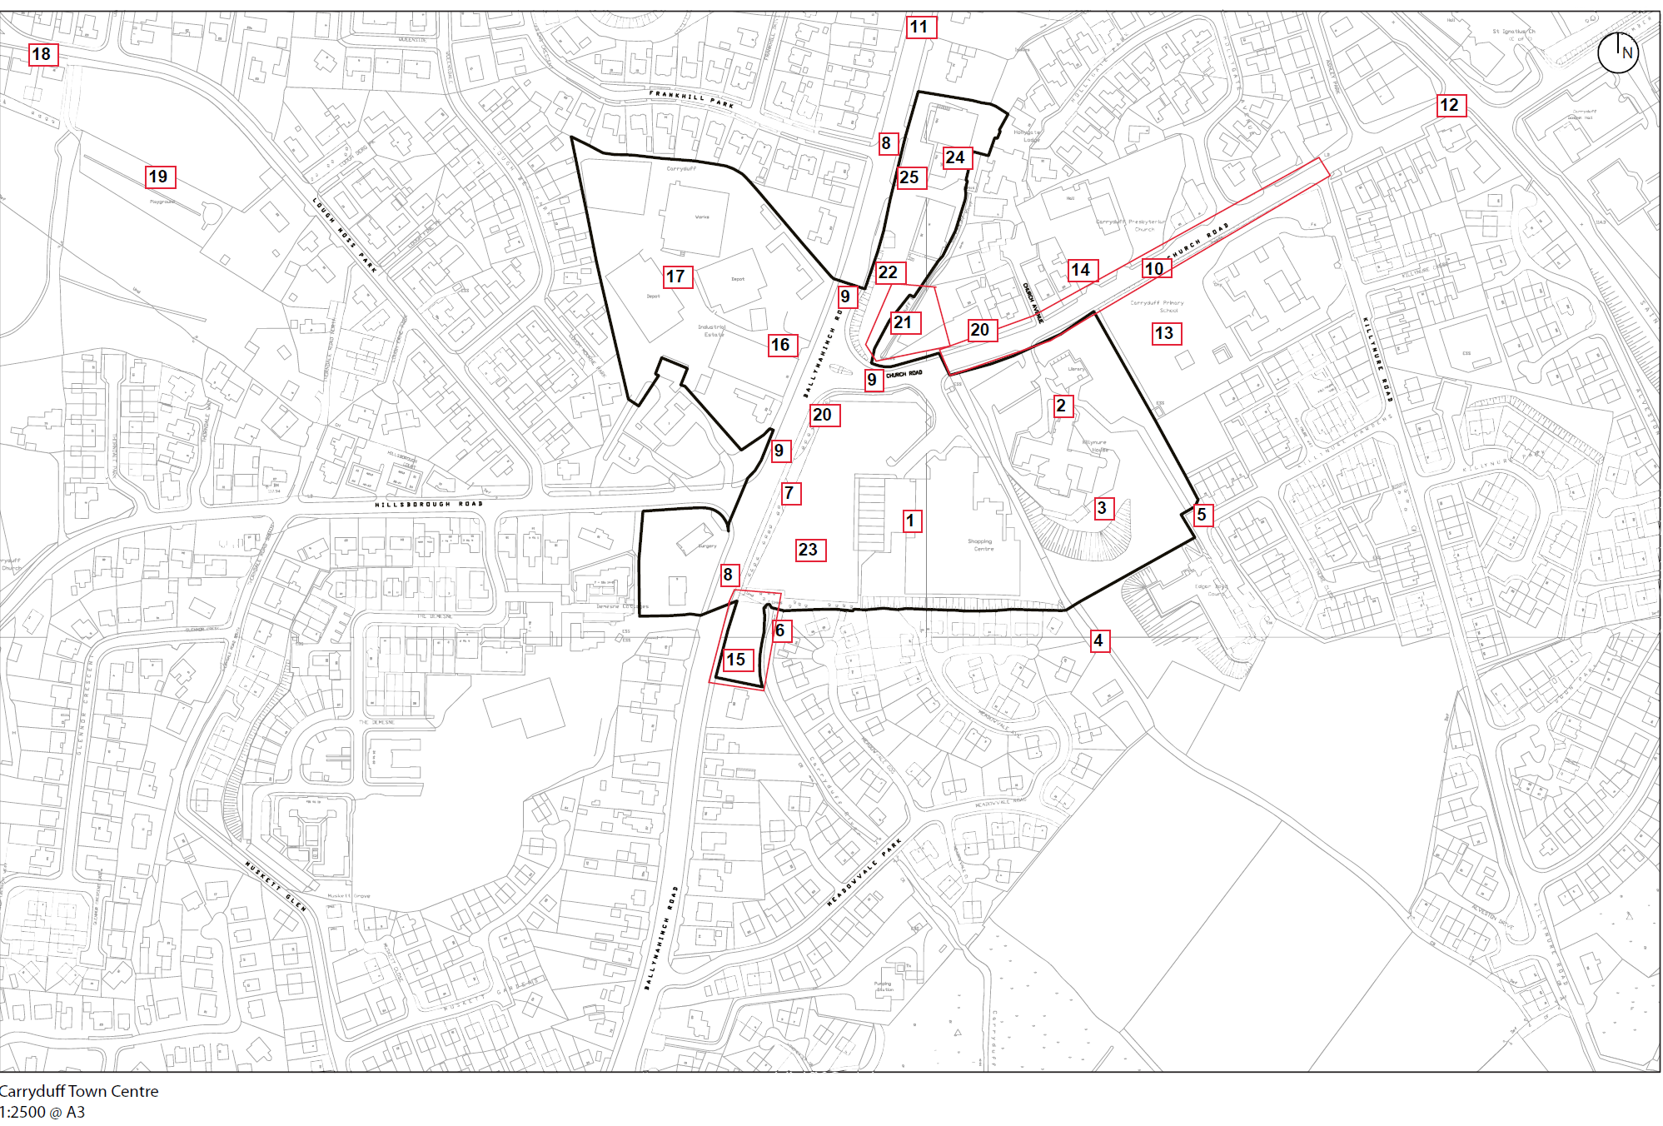

**Appendix 2 – Dundonald Urban Boundary Map**

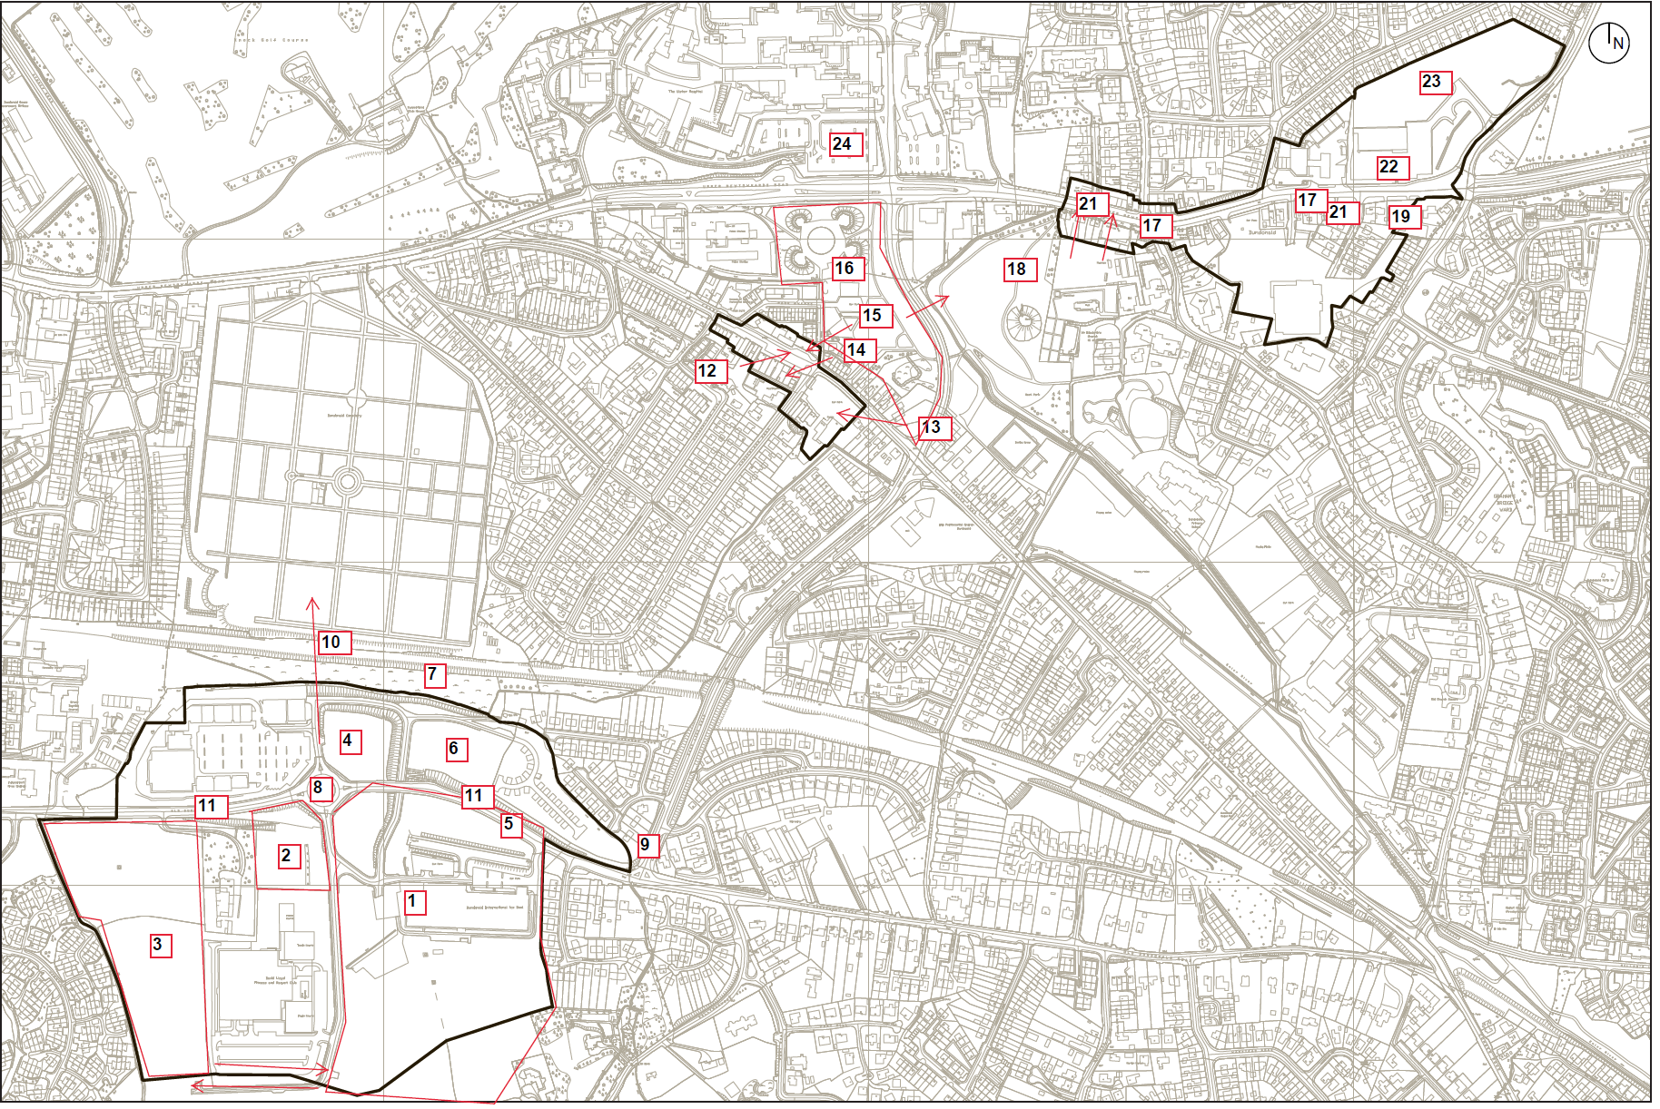

**Appendix 3 – Lisburn City Centre Urban Boundary Map**

